|  |  |
| --- | --- |
| Name |  |
| Class |  |
| Date |  |

Chapter 6: ICT Applications

 

|  |
| --- |
| **What the syllabus says you need to know:** |
| * 1. **Applications in manufacturing industries**  1. describe a range of computer controlled applications (e.g. robotics in manufacture and production line control) 2. discuss the advantages and disadvantages of using computer controlled systems rather than humans |
| * 1. **School management systems**  1. describe how systems are used to manage learner registration and attendance 2. describe how systems can be used to record learner performance 3. describe how systems can be used for organising examinations, creating timetables and managing teaching cover/substitution |

**Lesson Objectives:**

|  |
| --- |
| 1. Describe how computer controlled robots are used in the manufacturing industry |
| 1. Describe how schools use computer systems to manage learner registration attendance, record learner performance and organising examinations |
| 1. Discuss the advantages and disadvantages of using computer controlled systems in the manufacturing and education sectors |

**Useful links**

<https://ictlounge.com/html/ways_in_which_ict_is_used_part2.htm>

Find specific links in your class notebooks under the relevant sections (6.6 and 6.7)

|  |
| --- |
| 6.6 Manufacturing Applications |

**Overview of Industrial Robots:**

Manufacturing uses ICT (i.e automation) in a number of ways. See if you can list some areas of improvement by using robots:



* *Review: check your answers with the teacher and make corrections using a different colour pen*
* **Activity: Label the diagram**

**Using the keywords below, complete the labels on the diagram**

*Waist, shoulder, joints, wrist, attachment/tool, instructions*

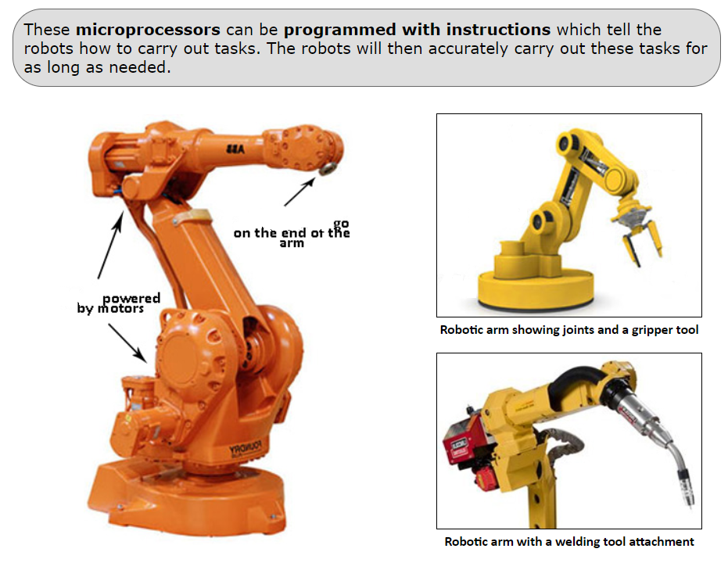

* **Activity: Typical jobs completed by robots**

Robots can be used to carry out many tasks, from lifting heavy objects to very delicate operations. Using the pictures as an aid, can you complete the table of tasks a robot might be used?

|  |  |
| --- | --- |
|  | Automotive - A WIN Group Company |
|  | Electronic Circuit Board Production. Automated Circut ... |
|  | BMW, General Motors among manufacturers using robots for ... |
|  | Fanuc Robotic Arm Lifting a Car - Robotic Gizmos |

* *Review: check your answers using the teachers slides and correct as necessary using a different colour.*
* **Activity: Advantages vs disadvantages**

Using full sentences, write 4 advantages and disadvantages of using robots in Manufacturing

|  |  |
| --- | --- |
| Advantages | Disadvantages |
|  |  |
|  |  |
|  |  |
|  |  |

* ***Extension****:*

*Identify two changes to the workers’ working environment that the use of robots has brought about:*

|  |
| --- |
|  |
|  |
|  |
|  |
|  |
|  |

* ***Want to aim higher?***

Go to your notebook and attempt the exam questions under “Exam Questions (6.6 Manufacturing Apps)” page

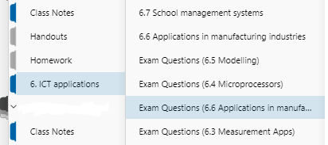

|  |
| --- |
| 6.7 School Management Systems |

* **Activity: Mind map**

Complete the mind map, adding anything you think a school might record or take note of during a school day, week or year

**Data recorded by schools**

* **Activity**

Read the following information and attempt the questions after

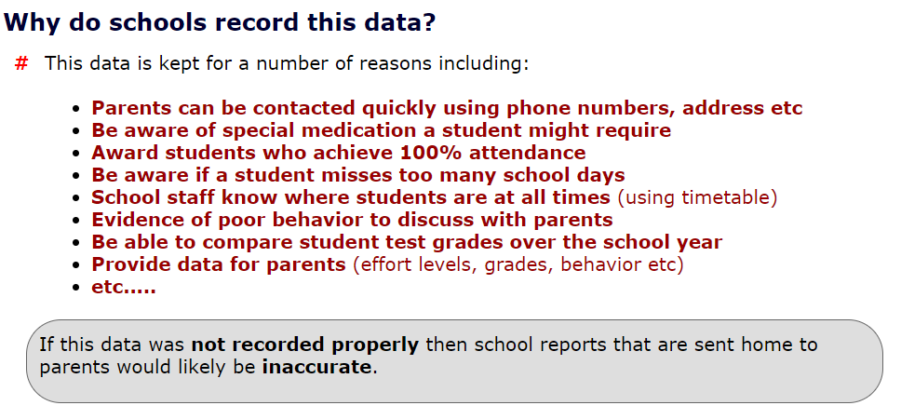

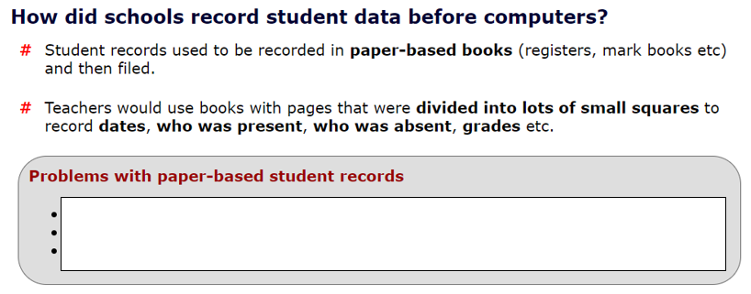

**(Think of 3 problems)**

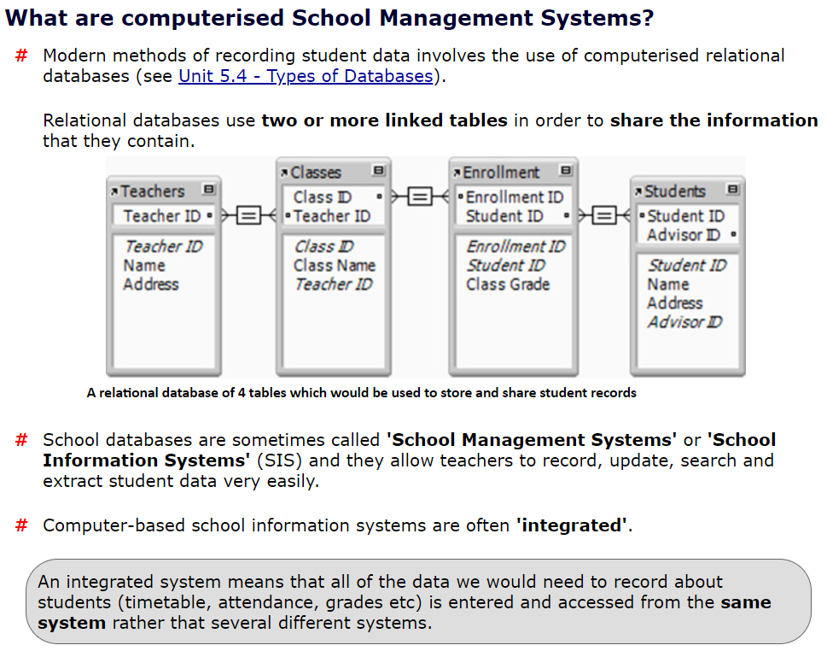

* **Activity: Advantages and Disadvantages**

Identify 3 advantages and 3 disadvantages of using a School management System

|  |
| --- |
|  |
|  |
|  |
|  |
|  |
|  |

* **Extension**

Complete the exam question

*“VAS are implementing a new SMS (School Management System) called Engage. It will be used to perform various admin tasks such as recording attendance, logging incidents/praise/achievement, recording exam and homework scores as well as provide a means of communication with parents.*

*Discuss the advantages of using this system rather than a paper-based management system:”*

|  |
| --- |
|  |
|  |
|  |
|  |
|  |
|  |
|  |
|  |
|  |

[8 marks]

|  |  |
| --- | --- |
| *Teacher Comments* | |
|  | |
|  | |
|  | |
|  | |
| *Student Response* | |
|  | |
|  | |
|  | |
|  | |
| *Circle or remove the monkeys depending on your confidence in the topic* | Cheering monkeyThinking monkeyCrying monkey |